LANDSCAPES OF THE MIND

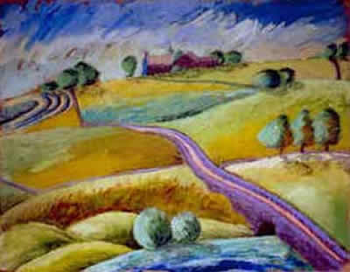
Our publication 'Landscapes of the Mind' invites the reader to travel with us on a quest towards an inner world that may shock and disturb, delight and depress, stir to laughter and tears. The physical backdrop of our work will be familiar to many: it is the dramatic moorland scenery around the Roaches in the Staffordshire Moorlands, close to the county boundaries that meet at Three Shire Heads.
We drew particular inspiration from the Knivedon Garden setting in Leek and from our school and community base at Warslow. These are the landscapes which gave us courage to explore that other shadowy borderland which spans the reaches of the mind. We wanted to chart the territory between 'mental health' and 'mental illness' - part of the same continuum of universal human experience.
We wanted to bridge that threatening gap that is born of 'normal' distinctions. By beginning to map our own inner journeys, we hope we can contribute not only to the mental health of individuals but also perhaps to the recovery process of the wider society.

